## Startup Failure Post-Mortems 2020 Second Update (8/18/20)

### Essential Products

Title: [Essential, Andy Rubin’s phone company, is shutting down](https://www.theverge.com/2020/2/12/21134985/essential-phone-shutting-down-andy-rubin-startup)  
Title Link: <https://www.theverge.com/2020/2/12/21134985/essential-phone-shutting-down-andy-rubin-startup>

Product: [Essential Products](https://www.cbinsights.com/company/essential)  
Product Link: <https://www.cbinsights.com/company/essential>

Consumer hardware startup Essential closed down in February 2020, following the flop of its Essential Phone launched in 2017 and other unfinished projects. Founded by Andy Rubin, the creator of [Android](https://www.cbinsights.com/company/android), the startup drew significant interest, raising over $330M. However, after a 2018 New York Times report revealed that Rubin had allegedly left Google due to sexual misconduct allegations, attention to the startup cooled. According to The Verge,

Essential was in the process of developing another phone called “Project Gem” with an unusual design. Rubin first teased the project in October 2019, but the company now says it has “no clear path to deliver it to customers.”

“Given this, we have made the difficult decision to cease operations and shutdown Essential,” the company writes in a blog post.

# Essential Products

CONSUMER PRODUCTS & SERVICES | Consumer Electronics  
[essential.com](https://essential.com/)

## Founded Year

2015

## Stage

Asset Sale | AssetsPurchased

## Total Raised

$330M

## About Essential Products

Essential Products is a company focused on creating consumer technology products for the 21st century. Founded by Andy Rubin, co-founder of Android, Essential Products is headquartered in Palo Alto, California.

## Essential Products Headquarter Location

380 Portage Avenue

Palo Alto, California, 94306,

United States

650-300-0000

Essential, Andy Rubin’s phone company, is shutting down

The phone startup is done after one flop  
By Jacob Kastrenakes @jake_k Feb 12, 2020, 1:19pm EST

Title Link: <https://www.theverge.com/2020/2/12/21134985/essential-phone-shutting-down-andy-rubin-startup>

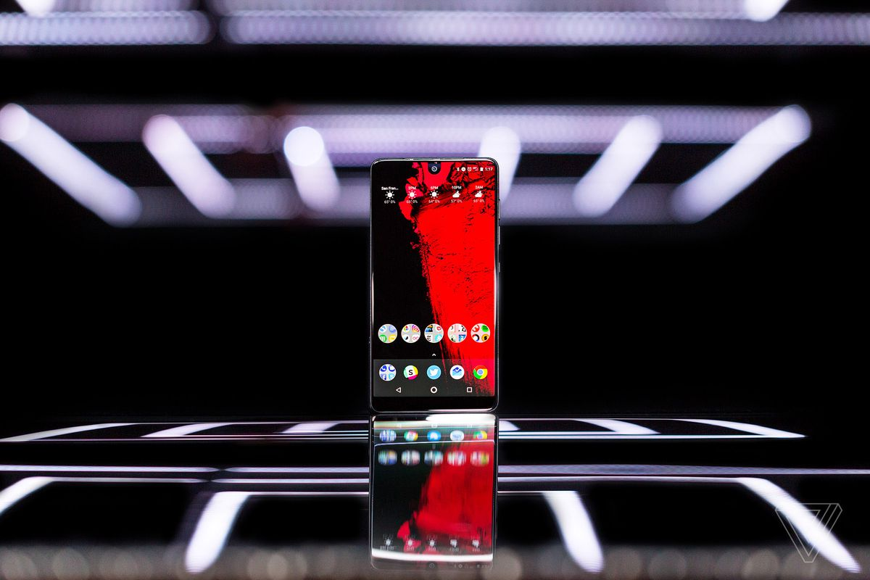

Photo by Vjeran Pavic / The Verge

Essential is shutting down less than three years after the startup unveiled its first smartphone. The company’s only complete product, [the Essential Phone](https://www.theverge.com/2017/8/18/16165040/essential-phone-review-android-andy-rubin), [sold poorly](https://www.theverge.com/2018/2/12/17004278/essential-phone-2017-sales-90k-units-sold-six-months-post-launch) and received mixed reviews. A follow-up phone [was canceled](https://www.theverge.com/2018/5/24/17391734/essential-cancels-phone-development-considers-sale-report), and a number of other promised devices — like a [smart home assistant](https://www.theverge.com/circuitbreaker/2017/5/30/15711258/essential-home-voice-assistant-andy-rubin) and [operating system](https://www.theverge.com/circuitbreaker/2017/5/30/15711162/ambient-os-essential-home-andy-rubin) — never materialized.

The startup was founded by Android creator Andy Rubin. While that initially drew hype and investment, it quickly turned backward on the company after [a *New York Times*report](https://www.nytimes.com/2018/10/25/technology/google-sexual-harassment-andy-rubin.html) drew attention to accusations of sexual misconduct against Rubin that allegedly led to him leaving Google.

Essential was in the process of [developing another phone](https://www.theverge.com/2019/10/8/20905525/andy-rubin-elongated-phone-essential-android) called “Project Gem” with an unusual design. Rubin first teased the project in October 2019, but the company now says it has “no clear path to deliver it to customers.”

“Given this, we have made the difficult decision to cease operations and shutdown Essential,” the company writes in [a blog post](https://www.essential.com/blog/essential-update).

Essential is done issuing updates for the Essential Phone, though it says the device will continue to work. [Newton Mail](https://www.theverge.com/2019/2/5/18212281/essential-newton-mail-app-back-available-ios-android-mac-windows-phone), which Essential [bought in late 2018](https://www.theverge.com/2018/12/7/18130853/essential-cloudmagic-newton-email-app-company), will also be shut down. Essential says it will continue to operate through April 30th.

The news is supposed to have no impact on Playground Global, a VC firm Rubin founded [that shares the same office space](https://www.theverge.com/2019/10/11/20910225/andy-rubin-playground-global-departure-essential-founder-ceo) as Essential, according to an Essential spokesperson. A Playground spokesperson said the firm is “proud to have supported” the team even though “commercial success was elusive.”

When Essential debuted its first phone in 2017, it seemed to have a lot going for it. The device had a premium build quality, the backing of Android’s creator, and a unique nearly all-screen design with a cutout camera notch that hadn’t been seen before.

But the phone’s design very quickly became standard fare — the iPhone X was released just months later, and a wave of notch knock-offs followed. And the Essential Phone itself wasn’t helped by some faults of its own: it was a Sprint exclusive in the US, confining it to the smallest nationwide carrier, and its camera was widely criticized by reviewers.

Essential also promised a wave of accessories for a magnetic module system built into the phone, but only two materialized: a 360-degree camera and a headphone jack adapter, which sold for $149.

Even as the startup struggled with sales and development of new devices, it continued to support its original phone. Six months after launch, [it put out three new color options](https://www.theverge.com/circuitbreaker/2018/3/1/17066192/essential-limited-edition-colors-photos-ocean-depths-matte-black-bronze-amazon), and the company continued to regularly update the phone’s software. As recently as September 2019, it was [updated to Android 10](https://www.theverge.com/2019/9/3/20847890/essential-phone-android-10-update-release-day) on day one of the operating system’s release.

Unable to break into the phone market with a traditional device, Essential started developing a much quirkier new device, seemingly hoping to strike a chord with consumers. It was never entirely clear what Project Gem would be good for, though. And apparently, Essential lacked the money — and interest from investors — to get it to market.